39) The Feed ‘N Ship Ranch fattens cattle for local farmers and ships them to meat markets in Kansas City and Omaha. The owners of the ranch seek to determine the amounts of cattle feed to buy so that minimum nutritional standards are satisfied, and at the same time total feed costs are minimized. The feed mix can be made up of the three grains that contain the following ingredients per pound of feed:

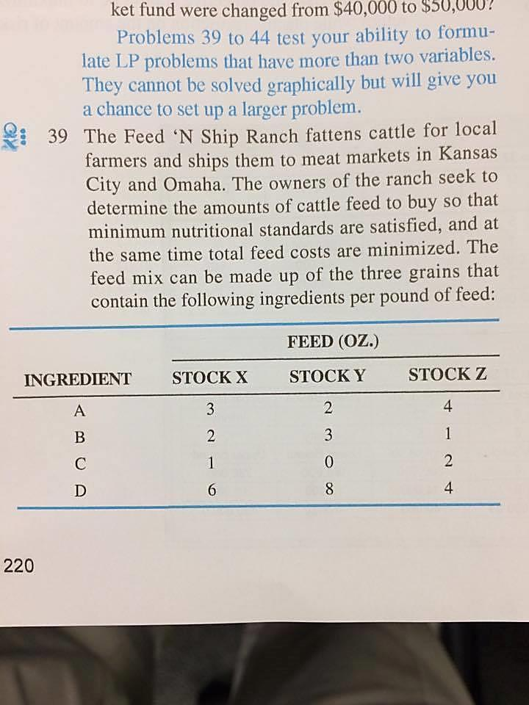

The cost per pound of stocks X, Y, and Z are $2, $4, and $2.50, respectively. The minimum requirement per cow per month is 4 pounds of ingredient A, 5 pounds of ingredient B, 1 pount of ingredient C, and 8 pounds of ingredient D.

The ranch faces one additional restriction: it can only obtain 500 pounds of stock Z per month from the feed supplier regardless of its need. Because there are usually 100 cows at the Feed ‘N Ship Ranch at any given time, this means that no more than 5 pounds of stock Z can be counted on for use in the feed of each cow per month.
- Formulate this as an LP problem.
- Solve using LP software.

